Name: Saroj Kumar Dash
Course: ECE-6310
Course Name: Intro to Computer Vision

Lab#1 – Convolution, separable filters, sliding windows

Problem Statement:
To implement 3 version of 7x7 mean filters.
Version 1 :- with basic 2d convolution
Version 2 :- with separable filters(1x7 and 7x1)
Version 3 :- with separable and sliding window

Solution Version 1:-- with basic 2d convolution

I made two separate function to separate the kernel multiplication.Image is a class that I have created to manage the data structure of the image rows, cols and pixels which reduces the number of arguments to pass to the methods.

Code:-
//Separated kernel multiplication operation
int kernel2dConv(image &iImg,int iCol,int iRow){

int r,c,sum=0;
int outPixel = 0;
int ker[7][7] = { //Now using a mean filter but later we can use any filter here
{1,1,1,1,1,1,1},
{1,1,1,1,1,1,1},
{1,1,1,1,1,1,1},
{1,1,1,1,1,1,1},
{1,1,1,1,1,1,1},
{1,1,1,1,1,1,1},
{1,1,1,1,1,1,1}};
int kSize = 7;
unsigned char *pInPixels = iImg.getPixels();

for( r=-(kSize/2); r<=(kSize/2); r++)
for(c=-(kSize/2); c<=(kSize/2); c++)
sum += (pInPixels[(iRow+r)*iImg.getCols() + (iCol+c)]*ker[c+(kSize/2)][r+(kSize/2)]);

outPixel = sum/(kSize*kSize);
return outPixel;
}

//do the main convolution operation here whoever uses this method should delete the returned pointer
//this method is clocked in main()
unsigned char *convolveSimple(image &iImg){
unsigned char *opPixels = NULL;
int r,c;
int sum;
opPixels = new unsigned char[iImg.getRows() * iImg.getCols()];
//Do convolve operation here
for(r=3; r< (iImg.getRows()-3); r++)
for(c=3 ; c<(iImg.getCols()-3); c++)
opPixels[r*iImg.getCols()+c] = (unsigned char)kernel2dConv(iImg,c,r);

return opPixels;
}

Output:-
Generates a smoothed output image named, out.ppm, which is a smoothed version of input image bridge.ppm. Which looks as below:-

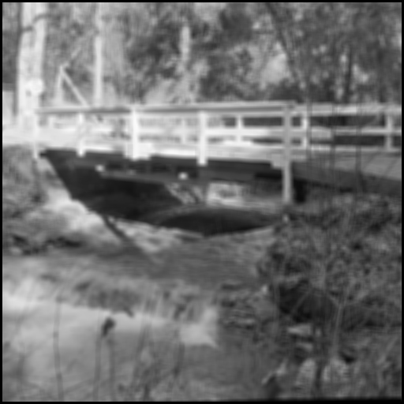

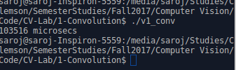
Time Clocked is :- 103516 microsecs

I have taken observation by measuring the time taken by the function convolveSimple().

Solution Version 2 :- with separable filters(1x7 and 7x1)

Code:

//Convolves a 1x7 kernel horizontally //@return: outPixSum : sum of kernel operation for the mean filter
int kernelSepHor(image &iImg,int iCol,int iRow){

int r,c,kSize = 7;
int outPixSum = 0;
int kerR[7] = {1,1,1,1,1,1,1};
int sum =0,temp =0;
unsigned char *pInPixels = iImg.getPixels();

// horizontal convolution
for( c=-(kSize/2); c<=(kSize/2); c++)
sum += pInPixels[(iRow)*iImg.getCols()+(iCol+c)]*kerR[c+(kSize/2)];

outPixSum = sum;
//std::cout<<outPixSum<<" "<<iCol<<" "<<iRow<<std::endl;
return outPixSum;
}

//Convolves a 7x1 kernel vertically
//@return: outPixSum : sum of kernel operation for the mean filter
int kernelSepVer(unsigned int *&pInPixels,int iCol,int iRow,int iW,int iH){

int r,c,kSize = 7;
int outPixSum = 0;
int kerR[7] = {1,1,1,1,1,1,1};
int sum =0,temp =0;

// vertical convolution
for( r=-(kSize/2); r<=(kSize/2); r++)
sum += pInPixels[((iRow+r)*iW)+(iCol)]*kerR[r+(kSize/2)];

outPixSum = sum;
//std::cout<<outPix<<" "<<iCol<<" "<<iRow<<std::endl;
return outPixSum;
}

//do the main convolution operation here whoever uses this method should release the returned pointer.
//this function is time clocked
unsigned char *convolveImage(image &iImg){
unsigned char *opPixels = NULL;
unsigned int *tmpPixels = NULL;
int r,c,kSize = 7;
int sum;
//allocate memory for the out Pixel pointer
opPixels = new unsigned char[iImg.getRows() * iImg.getCols()];
tmpPixels = new unsigned int[iImg.getRows() * iImg.getCols()];

//Do horizontal convolution, output stored in a temporary array
for(r=0; r<iImg.getRows(); r++)
for(c=3 ; c<(iImg.getCols()-3); c++)
tmpPixels[r*iImg.getCols()+c] = kernelSepHor(iImg,c,r);

//Do vertical convolution
for(c=3; c<(iImg.getRows()-3); c++)
for(r=3 ; r<(iImg.getCols()-3); r++)
opPixels[r*iImg.getCols()+c] =
(unsigned char)(kernelSepVer(tmpPixels,c,r,iImg.getCols(),iImg.getRows())/(kSize*kSize));
delete(tmpPixels);
return opPixels;
}
Output:-
Generates a smoothed output image named, outv2.ppm, which is a smoothed version of input image bridge.ppm.
Which looks as below:-

Output Validation:-
Linux version of diff on out.ppm and outv2.ppm proves both the files are equal.
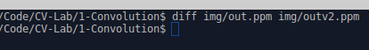
My machine result:-

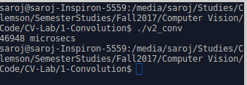
Time Clocked:- 46948 microsecs

Solution Version 3 :- with separable and sliding window
Code:
//Kernel sliding window algorithm //a 1x7 filter is slided horizontally in the image
int kernelSepSlideWinhor(image &iImg,int iCol,int iRow){

int outPixSum=0;
static int prev1stColSum = 0,prevSum = 0;
int sum = 0;
unsigned char *pInPixels = iImg.getPixels();

//kernel separable details
int ker[7] = {1,1,1,1,1,1,1};
int kSize = 7;

//first pixel of the row, iCol = 3
if( (kSize/2) == iCol){
//Compute the full kernel and save the prev1stColSum and the prevSum
for( int c=-(kSize/2); c<=(kSize/2); c++)
{
//we increment horizontally
sum += (pInPixels[(iRow)*iImg.getCols() + (iCol+c)]*ker[c+(kSize/2)]);
if((c+(kSize/2) == 0)) //saving the first convolved value
prev1stColSum = sum;
}
//save the prevSum
prevSum = sum;
}//not a first pixel of the row, iCol!=3
else{
int lastColSum=0,nb1stColSum=0;
//Compute the last col sum, lastColSum
lastColSum = pInPixels[iRow*(iImg.getCols()) + (iCol+(kSize/2))];
nb1stColSum = pInPixels[iRow*(iImg.getCols()) + (iCol-(kSize/2))];
//compute sum, sum = prevSum - prev1stColSum + lastColSum & save values for next iteration
sum = prevSum - prev1stColSum + lastColSum;
prevSum = sum;
prev1stColSum = nb1stColSum;
}
outPixSum = sum;
return outPixSum;
}

//kernel separable filter applied vertically //a 7x1 filter is slided vertically in the image
int kernelSepSlideWinVer(unsigned int *&pInPixels,int iCol,int iRow,int imgWidth,int imgHeight){
int outPixSum=0;
static int prev1stRowSum,prevSum;
int sum = 0;
//unsigned char *pInPixels = iImg.getPixels();

//kernel separable details
int ker[7] = {1,1,1,1,1,1,1};
int kSize = 7;

//first pixel of the row, iCol = 3
if( (kSize/2) == iRow){
//Compute the full kernel and save the prev1stRowSum and the prevSum
for( int r=-(kSize/2); r<=(kSize/2); r++)
{
sum += (pInPixels[(iRow+r)*imgWidth + (iCol)]*ker[r+(kSize/2)]);
if((r+(kSize/2)) == 0)
prev1stRowSum = sum; //which is the first convolved value
}
//save the prevSum
prevSum = sum;
}//not a first pixel of the row, iCol!=3
else{
int lastRowSum=0,nb1stRowSum=0;
//Compute the last col sum, lastRowSum
lastRowSum = pInPixels[((iRow+(kSize/2))*(imgWidth)) + (iCol)];
nb1stRowSum = pInPixels[((iRow-(kSize/2))*(imgWidth)) + (iCol)];

//compute sum, sum = prevSum - prev1stRowSum + lastRowSum
sum = prevSum - prev1stRowSum + lastRowSum;
prevSum = sum;
prev1stRowSum = nb1stRowSum;
}

outPixSum = sum;
return outPix;
}

//do the main convolution operation here we will clock this function
//whoever uses this method should release the returned pointer
unsigned char *convolveImage(image &iImg){

unsigned char *opPixels = NULL;
unsigned int *tmpPixels = NULL;
int kSize = 7;
int r,c;
int sum;
//allocate memory for the out Pixel pointer
opPixels = new unsigned char[iImg.getRows() * iImg.getCols()];
tmpPixels = new unsigned int[iImg.getRows() * iImg.getCols()];

//Do convolve operation horizontally
for(r=0; r<(iImg.getRows()); r++) //rows will be the same here
for(c=3 ; c<(iImg.getCols()-3); c++)
tmpPixels[r*iImg.getCols()+c] = kernelSepSlideWinhor(iImg,c,r);

//Do convolve operation vertically
for(c=3; c<(iImg.getRows()-3); c++) //rows will be the same here
for(r=3 ; r<(iImg.getCols()-3); r++)
opPixels[r*iImg.getCols()+c] = (unsigned char)(kernelSepSlideWinVer(tmpPixels,c,r,
iImg.getCols(),iImg.getRows())/(kSize*kSize));

delete(tmpPixels);
return opPixels;

}

Output for version 3:-
Generates a smoothed output image named, outv3.ppm, which is a smoothed version of input image bridge.ppm.
Which looks as below:-

Output Validation:-
Linux version of diff on out.ppm and outv2.ppm proves both the files are equal. Diff on out.ppm and outv3.ppm says both are equal. Diff on outv2.ppm and outv3.ppm is also successful.
My machine result:-
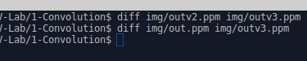

Time Clocked:- 25161 microsecs
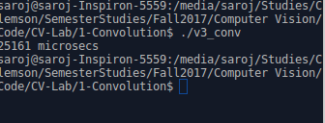

Conclusion:-

 | Time Taken(µs) | %time taken vs V1
2dConvV1(basic 2d Convolve) | 103516 | 0
2d ConvV2(kernel Separable) | 46948 | 54%
2d ConvV3  (separable + sliding Window) | 25161 | 75%

Thus we can observe that the version is 75% more efficient i.e. takes .25 times of the basic 2d Convolution algorithm. Therefore a combination of separable and sliding window operation is the most efficient way for the convolution operation on the image.

